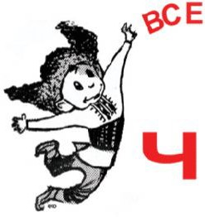
Ukrainian School Readathon Sponsor Chart

Due April 26, 2014!

Ім’я і прізвище/Student Name: Кл./Grade: Скільки книжок/Total Number of Books Read:
Скільки датків/Total Amount of Funds Raised:

Учні /Students: *Do not go door-to-door or ask strangers to sponsor you! Ask relatives and friends.
Collect your pledges towards the end of the Readathon period in this envelope, and turn it in with your Reading Chart!
Спонзори: Просимо Вашу підтримку!
Учні читають по-українськи та помагають збирати фонди на нашу українську школу!
Sponsors: this Readathon is designed to augment the student’s reading skills in Ukrainian, as well as to raise badly needed funds for our Ukrainian School in Bethesda MD.
You may choose to pledge a flat amount, or a certain amount per number of books read.
Every 15 minutes of reading counts as one book.
**Checks may be made out to “Ukrainian School” **
We are a 501(3)c organization, and your contribution is fully tax-deductible.

Thank you for your support! Дякуємо за Вашу підтримку!

Спонзора Ім’я і Прізвище  Sponsor Name | Flat Amount Pledged | OR  Amount Pledged Per Book | Total Amount Donated | Donation  Collected √

Ukrainian School Readathon Sponsor Chart continued.
**Checks may be made out to “Ukrainian School”.
We are a 501(3)c organization, and your contribution is fully tax-deductible.
Thank you for your support!

Sponsor Name | Flat Amount Pledged | OR  Amount Pledged Per Book | Total Amount Donated | Donation  Collected  √

