Ukrainian School
Readathon

February 1 to April 25, 2020
1-го лютого – 25-го квітня, 2020 р.

Students: improve your reading
and raise funds for our school!

Step 1: ЗНАЙДИ СПОНСОРІВ - Get sponsors – ask your parents, grandparents, aunts and uncles, friends – anyone who would like to support you! They can promise a flat amount, or an amount per book read! Fill out the Sponsor Chart on the Collection envelope!

Step 2: ЧИТАЙ І ЧИТАЙ! Read, read, read! Any book or magazine in Ukrainian (or even about Ukraine) counts! Every 15 minutes you spend reading counts as one book – so you can put the same title down multiple times – just list the pages/time spent reading. Someone can read to you, and that counts too! Reading for homework counts as well! Be sure to keep filling out your Reading Chart as you go!

Step 3: ЗБИРАЙ ДАТКИ - Collect pledge money from your sponsors at the end of our Readathon period (checks may be made out to “Ukrainian School”) and put it in the Collection Envelope. Or ask your sponsors to donate online through our PayPal button on the Readathon website, and just note your name on the payment page. Here’s the link: ukrainianschoolreadathon.weebly.com

Step 4: ВІДДАЙ ВЕСЬ МАТЕРІАЛ - on April 25th, turn in your Reading Chart and your Collection Envelope with the Sponsor Chart on it! Make sure your name is on everything! (Lose the forms or envelope? Download them from our Readathon website or use plain paper; use any envelope labeled with your name).

Step 5: НАГОРОДИ! Receive prizes for all your hard work!!! See the other side of this sheet for the prizes you can win! Prize for first book will be given out starting February 8th, with remaining prizes given after the conclusion of the Readathon, on May 2nd and 9th. RAFFLE ITEMS will be available again this year. After the reading charts are tallied each participant will receive raffle tickets according to the highest level achieved in reading. Raffle items will be on display May 2nd and 9th, and winning tickets will be drawn May 9th at the end of the school day.

Questions? Contact Sarah Tweed at olehsarah@verizon.net
See our Readathon website: ukrainianschoolreadathon.weebly.com

Readathon Prizes

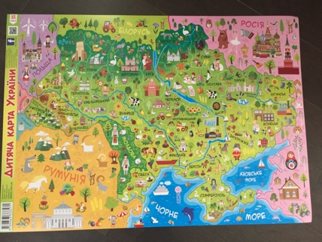
Every 15 minutes of reading = 1 book! Кожних 15 хвилин читання = 1 книжка!

Прочитай 1 книжку - Read 1 book: get one prize book from the Paddington series!+ 1 Raffle ticket

20 книжок - 20 books:
also get a tiny glass animal figurine + 4 Raffle tickets

10 книжок - 10 books:
also get a Ukraine poster map + 3 Raffle tickets

5 книжок - 5 books:
get a Ring Pop! + 2 Raffle tickets

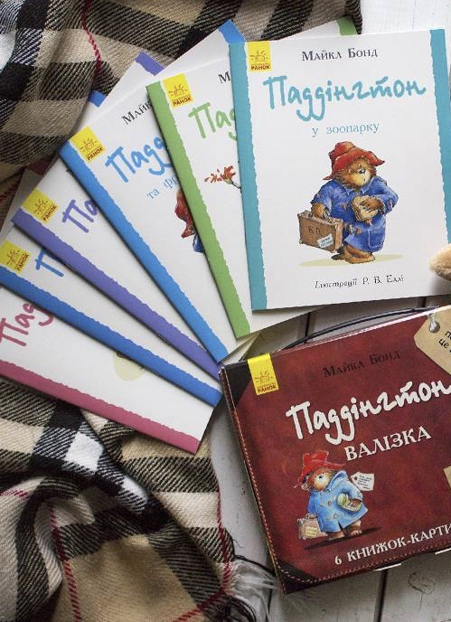
40 книжок - 40 books:
also get a Koza Dereza keychain! +5 Raffle tickets

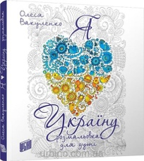
60 книжок – 60 books: Ukraine Coloring Book + 8 Raffle tickets

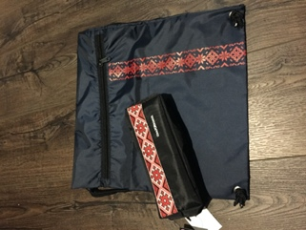
80 книжок – 80 books: also get a large glass animal figurine! + 10 Raffle tickets

100 книжок – 100 books:
Vyshyvanka string bag and pencil case! + 12 Raffle tickets

Additional prizes for the top 3 readers and top 3 fundraisers!

All Raffle tickets will be eligible for many Ukraine-themed prizes. The competition winners will be announced and the raffle drawing will take place on the last day of classes (Saturday before the picnic) on May 9th. The Raffle prizes will go on display in May.

The top 3 fundraisers in the school will also receive a Ukrainian-themed cap!

